[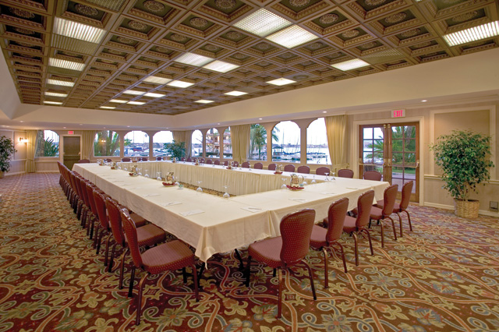](http://www.hisandiegoonthebay.com/gallery/gallery28.html)

**NCF**

**T**he

**N**ational

**C**redentialing

**F**orum

**C**redentialing

**F**orum

**SAVE THE DATE**

National Credentialing Forum will be held **IN PERSON** Feb 2 and 3, 2023

**National Credentialing Forum**

**7:30 am – 4:30 pm (PST), Thursday, February 2, 2023**

**7:30 am – 3:30 pm (PST), Friday, February 3, 2023**

**Participation in the February Forum is limited to 50 registrants; due to increased interested from various new accreditors & regulatory organizations, a change this year will be invitation will be extended to 1 participant per organization. Those will be given priority registration:**

1. **Prior multi-year, active participants – 1 per organization**
2. **Waitlist: New Accreditors & regulatory organizations**
3. **Waitlist: Prior single/infrequent participants & new participants (via application)**
4. **Waitlist: 2nd representative to organizations.**

**Recent participants (#1) and those scheduled to be on the agenda, must confirm their attendance by October 31, 2022. After November 15th, 2022 seats will open to waitlist as previously described.** This size limit has been kept in the spirit of carrying on with the concept of maintaining a diverse dialog and manageable “round table” discussion forum. Tentative topics are NCF Charter, Mission Statement, Participation expectations, and potential for volunteering for “work groups” between annual meetings.

**WE NOW ACCEPT ELECTRONIC REGISTRATION & CREDIT CARD PAYMENT**

Registration **$350 – REGISTRATION OPENS 10/7/22**

***We now have a new electronic Payment and Registration option.***

***[www.winstaff.com/ncf/meetings.htm](http://www.winstaff.com/ncf/meetings.htm)***

***National Credentialing Forum***

***If your organization requires a W-9 form, contact***

[medstaffprof.palmer@gmail.com](mailto:agippe@osteotech.org)

**Past Participants:** If writing a check, registration must be received on or before November 15, 2022 to reserve your priority reservation.

**New & Wait List Participants:** If writing a check, registration and payment must be received on or before December 15, 2022.

**National Credentialing Forum**

**c/o Maggie Palmer**

**608 Chalk Hill Lane**

**Murphy, Texas 75094**

*Refunds: Cancelations within 30 days of Forum 50% refund; ~~15 days prior 25% refund; 3 days prior 0%~~. Requests for refunds will be considered on an individual basis and will be issued 30 days post conference. This assists us in managing our commitments to the hotel block and cost for food, etc.*

Contact Maggie Palmer with questions (858-213-8942);

or: medstaffprof.palmer@gmail.com

(Print Name, Title and email of Each Attending)

(Print Name, Title and email of Each Attending)

Name of Organization:________________________________________

Phone Number(s):___________________________________________

Email:_____________________________________________________

* Charges are calculated to cover meeting costs and damages due to hotel contract cancellation.

Should all funds not be used, they will be reserved for next year’s deposit.